The impact of Opioid related deaths in the United States

Nytina Cooks (918752892)

San Francisco State university

Econ 690-01 - Sudip Chattopadhyay

*Abstract*

The opioid epidemic is a large detriment to society and costs the nation millions of dollars a year in healthcare costs. In order to determine the effects of opioid overdoses on society we are asking the following questions: What are the key factors that contribute to Opioid deaths in the US states, how do opioid deaths in states impact the public costs of Medicare and Medicaid, and What kind of states are the most afflicted due to opioid deaths in the last two decades? We use two different econometric models to determine the overall rate of opioid related deaths and the cost based on healthcare expenditures. The average of the opioid deaths and costs amounts to about 16,242 deaths and approximately $869 million in healthcare costs with almost half of those coming from states with high levels of manufacturing as a form of employment.

**Introduction**

*Background*

The rise in the prescription of opioids in the medical field during the first couple decades of the 21st century has had a major impact on the health and addiction status of many patients in the united states. The prescribing of Opioid drugs has not only led to prescription drug addictions but also manifested into addictions to other illicit drugs. While there are very large impacts on the lives of individuals directly affected it is important to also look at the impact on a societal level. Understanding the impact on a greater society would ideally act as motivation to work towards enacting more rehabilitation/preventative measures to halt the effects of opioid related deaths. Some of the motivation behind this research is to determine the cost effects of opioid usage and addiction. It is also important to look at the impact on a state level for discovery of which states are more impacted by opioid related deaths.

*key factors that contribute to Opioid deaths in the US states/ policy issues*

When looking at the effects of the opioids there must be an analysis of the different factors that lead to deaths associated with opioid usage. Specific demographic information would be able to aid in the identifying of specific groups of people to see what kind of preventative measures should be taken to combat opioid related deaths. Information such as where and who the most prescriptions are coming from would reveal what measures need to be taken towards reducing as many opioid deaths as possible.

*public costs of Medicare and Medicaid*

Because opioid use poses a health risk there are many circumstances in which medical and professional intervention is necessary. Medicare and Medicaid are both health care programs that are offered through the government and therefore associated with public costs. Medical care in the midst of opioid usage, rehabilitation, as well as medical costs associated with the deaths are all accumulated to make up the costs of opioid usage to society. These deaths have a direct correlation to the cost of Medicaid and Medicare which should be observed in order to understand the full effect of the opioid crisis.

*states are the most afflicted due to opioid deaths*

Some areas may be affected more by the opioid crisis than others due to differences within the state and the nature of the environment that state may harbor. In order to get the most impact out of measures being enacted to reduce opioid related deaths may need to be targeted to a more specific group of people such as those within a state as opposed to the entire country. Factors such as GDP, unemployment, income, and more within a state would aid us in determining what needs to be addressed in each state to have the greatest benefit in battling opioid abuse and deaths. It is also important to measure the impact of the deaths on each state which would give insight on which areas are affected the most by opioid related deaths.

*Research Questions*

Research into the opioid usage in the US will provide us with answers to the following questions: What are the key factors that contribute to Opioid deaths in the US states, how do opioid deaths in states impact the public costs of Medicare and Medicaid, and What kind of states are the most afflicted due to opioid deaths in the last two decades? These questions will reveal to us the nature in which the country was impacted both socially and economically. Not only could these deaths have had major impact on the lives of not only patients but other Americans as well; this in addition to potential large economic impact surrounding the health care for patients with opioid associated casualties and illnesses.

*Supply and demand of opioids*

The opioid market started seeing an increase in prescriptions starting in the 1990s, initially these drugs had a higher price and were not as in demand as they have become in more recent times. Over the course of years as more people have been prescribed these drugs the demand has increased significantly to the point of opioids acting as an inelastic good as people are unable to go without it. With more people using opioids to soothe pain due to injury and chronic illness Opioids have become a crucial part in the lives of many. On a supply and demand curve we would see a shift in the demand for opioids with an inelastic supply curve set at a much lower price point. This lower price point was set in place by a government subsidy that allowed for these drugs to be priced more accessibly. Dasgupta (2018) provides the fact that Out-of-pocket prices for prescription opioids declined by an estimated 81 percent between 2001 and 2010”. Set at a lower price these drugs had become more accessible along with increased number of prescriptions and lack of regulation to these addictive drugs which outlines the issue surrounding the prominence of opioid usage and deaths in the United States.

*Data used*

The data that has been collected and used for this research aids in discovering which states are more likely to be affected by opioid related deaths based on several different factors. These factors are comprised of demographic and socioeconomic information to reveal to us to what extent these variables predispose individuals to risk of opioid related death; and which states are more at risk for being affected by opioid related death based on the prevalence of these factors impacting their populations.

*Methodology*

To gather the results for both the effects of state level impact and the impact on the nation in the form of spending, there are two separate models to gather the results of each. For this we simply input the demographic and socioeconomic information collected separated by state and year to determine the overall impact in each case.

**Background and previous research**

Background

The prescribing of opioids that has erupted is stemming from patient usage to treat chronic pain and illnesses. The highly addictive drug has a history of being prescribed in high volume to patients for a variety of reasons. Scavette (2019) states that 86 percent of patients using opioids were using them for noncancer pain; this demonstrates a very broad area of patients that were able to access these drugs through their healthcare providers. As a result of this the market for opioids has moved into a secondary market due to such high demand as many patients have become addicted to opioids, translating to increasing healthcare costs. Kirson 2017 states average annual health care spending on a person who abused opioids in 2012–2015 was $14,810 more than spending on someone who did not abuse opioids. The secondary market for these opioid painkillers has introduced new synthetic opioids which Sacavette (2019) states, caused overdose deaths at a higher rate than other types of opioid, making it important to take the right course of action.  
*previous research*

The effects of opioid usage in the United States are an important topic that has been researched prior. The role of opioids in the country has primarily been evaluated for its economic impact on a nationwide scale. There has also been some looking into some smaller area impacts and the impact that socioeconomic variations bring about. These smaller areas of impact amount for a great amount of the costs associated with opioid related deaths. Scavette, 2019 states that there are difficulties in finding the costs accrued by the opioid epidemic but reenforces the decision to collect information on a variety of categories to reflect societal cost as studies that they had come across had employed this method of data collection. Dasgupta (2018) finds the unprecedented 20-year difference in life expectancy between the healthiest and least healthy counties is largely explained by socioeconomic factors correlated with race/ ethnicity, behavioral and metabolic risk, and health care access. Categories such as labor force participation have been noted as having affected the cost associated with the opioid pandemic with an emphasis on specific demographics being more likely to fall into the categories that have contributed to this increase in cost for the nation. Scavette (2019) states that labor force participation has a negative relationship with the volume of opioids being prescribed suggesting that 43% percent of the observed decline in the male labor force participation rate between 1999 and 2015 could be attributed to the increase in opioid prescriptions during that time. Details such as these allow us to determine who is having the hardest time in terms of demographics and states with the opioid epidemic, thus having the greatest contribution of cost to the nation. Scavette (2019) states, “For fatalities, there are the health-care costs of treating overdosed patients and the losses in future productivity. Much of the lost productivity is borne by the deceased’s family and the private sector. Given that the average age for an overdose fatality is 41, which is considered prime working age,23 the losses in future productivity are quite high. However, these losses also show up in federal, state, and local tax receipts”. Knowing this kind of information is crucial to aiding and supporting law making decisions to combat the opioid epidemic and prevent increasing costs from healthcare expenditures which is expected to worsen without any action. Scavette (2019) suggests that A cost estimate of the opioid epidemic by the Council of Economic Advisors (CEA) placed the total cost in 2015 at $504 billion for the nation, with an expectation for that figure to grow if the crisis worsened. We will be looking into some of the same demographics along with others to further analyze the opioid epidemic and costs that are being accrued as a result to determine which factors are having the largest impact.

**Data Description**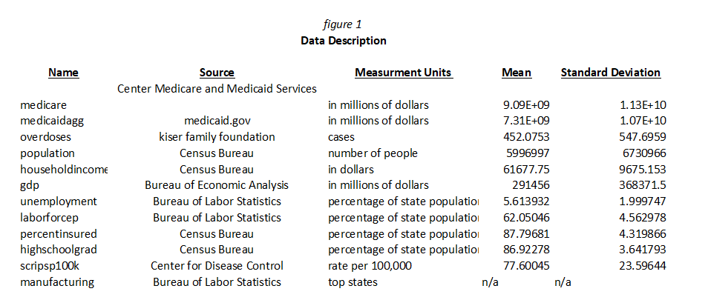

The data collected is separated into two separate categories being the health care associated costs (Medicare and Medicaid), and costs associated with demographic information such as lifestyle differences, prominence of certain industries in state of residence, and socioeconomic information.

**Medicare:** The Medicare spending variable listed as Medicare is an accumulation of Medicare costs in the millions by state and year. This information was provided by the centers for Medicare and Medicaid services.

**Medicaid**: The Medicaid variable is the total spending on Medicare by state and year in the millions. The information used to compile the data was taken from Medicaid.gov.

**Overdoses**: The number of opioid overdoses is the number of overdoses in a given state during each year. The data for this variable was provided by the Kiser Family Foundation.

**Population**: The population variable lists the population number in a given state per year. This data was provided by the Census Bureau for accurate values.

**Household income:** The median household income variable lists the average household income per state each year. The data for this variable is also from the Census Bureau.

**GDP:** The state GDP variable provides the GDP in the millions per state in a given year. The data for this variable is taken from the Bureau of Economic Analysis website.

**Unemployment:** The unemployment variable gives us the percentage of a states unemployed. The information used for this variable can be found on the website for the U.S. Bureau of labor statistics.

**Laborforcep:** The labor force participation rate variable gives us the percentage of a state’s population participating in the labor force. The data for this variable can also be found on the website for the U.S. Bureau of Labor statistics.

**Percentinsured**: The percent insured variable Provides us with the percentage of a state’s population that has any form of health insurance coverage. This information can be found on the website for the US Census.

**Highschoolgrad:** The percent high school graduate variable provides the percentage of adult high school graduates in a state’s population per year. This information is found on the website for the United States Census Bureau.

**Manufacturing**: Manufacturing jobs variable is based on the states that are ranked to have the largest percentage of manufacturing jobs in the nation. This variable differentiates manufacturing states from nonmanufacturing states using binary 0 for not applicable and 1 for applicable. This data is derived from an article on Construct Connect using data from the Bureau of Labor Statistics.

**scripsp100k:** The prescription rate variable gives us the rate of opioid prescriptions dispensed per 100 people for each year from 2006. This information is found on the website for the Centers for Disease control.

In addition to these variables we have collected we also have variables that have been created in by combining the base variables in a variety of ways. The recession variable is formed by compiling years before 2007, totalpresmillion is created by using (scripsp100k/100)*(population/1000000), recmanu is the recession variable* manufacturing, logoverdoses is the log of the overdoses variable, logtmcaremcaidmlreal is the log of (medicare*medicaidagg), and tmanufacturing is t*manufacturing.

*Econometric models*

To retrieve the results of the data compilation for each of the variables per state we will be creating two primary econometric models. Two of the greatest areas of impact brought about by the opioid pandemic are the number of deaths being experienced because of opioid abuse and the public costs associated with opioid abuse. The overdose model will be measuring the number of overdoses in a year by state. The cost model will be calculating total combined Medicare and Medicaid costs per state in a year. Both of these models will be using demographic and socioeconomic variables for each state in order to calculate the impact of each variable on either the total number of overdoses or the total cost associated with the opioid epidemic. These variables include labor force participation, levels of prescription, per capita income, state GDP, unemployment, population, percentage of insured people, and percentage of high school graduates. The usage of dummy variables will be present in order to obtain values for specific states and years. The dummy variables in being used will have the following names yeard1 through yeard18 for the year dummy; and state1 through state51 for the state dummy.

*Equation 1*

$Overdoses=β_{0}+18 year dummies+51 state dummies+β_{1}x_{1}+β_{2}x_{2}+β_{3}x_{3}+β_{4}x_{4}+β_{5}x_{5}+β_{6}x_{6}+β_{7}x_{7}+β_{8}x_{8}+β_{9}x_{9}+β_{10}x_{10}+β_{11}x_{11}+u$

* In this equation (equation 1) we use the 18-year dummies and 51 state dummies
  + $β_{1}$ through $β_{11}$ are the beta coefficients that are associated with $x_{1}$ through $x_{11}$ that are the variables that are listed in figure 1

*Equation 2*

$Total Cost=Y_{0}+18 year dummies+51 state dummies+Y_{1}Overdose+Y_{2}x_{2}+Y_{3}x_{3}+Y_{4}x_{4}+Y_{5}x_{5}+Y_{6}x_{6}+Y_{7}x_{7}+Y_{8}x_{8}+Y_{9}x_{9}+Y_{10}x_{10}+Y_{11}x_{11}+u$

* In this equation (equation 2) we use the 18-year dummies and 51 state dummies
  + $Y_{1}$ through $Y_{11}$ are the beta coefficients that are associated with $x_{1}$ through $x_{11}$ that are the variables that are listed in figure 1

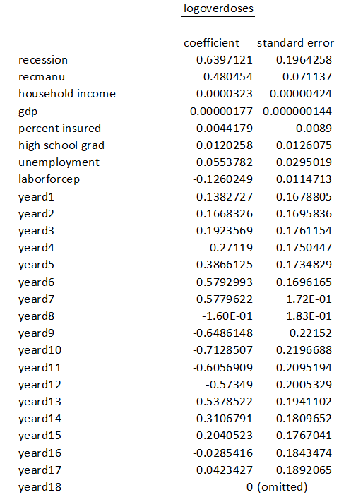Estimation Results

Figure 2

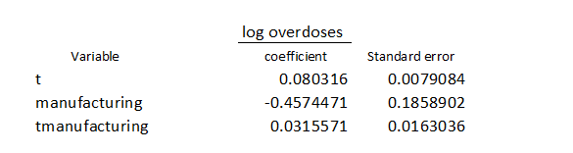

The regression results above (figure 2) account for the variables recession, recmanu, householdincome, GDP, percentinsured, highschoolgrad, unemployment, laborforcep and all available years. For every unit increased for percent insured, laborforce participation, manufacturing, and years 2008 through 2017, there is a decrease in the rate of overdoses. We see an increase in the rate per increase per one unit for recession, recmanu, householdincome, GDP, high school grad rate, unemployment, and remaining years. All variables besides percent insured and high school grad rate are statistically significant based on a significance set at 10%.

Figure 3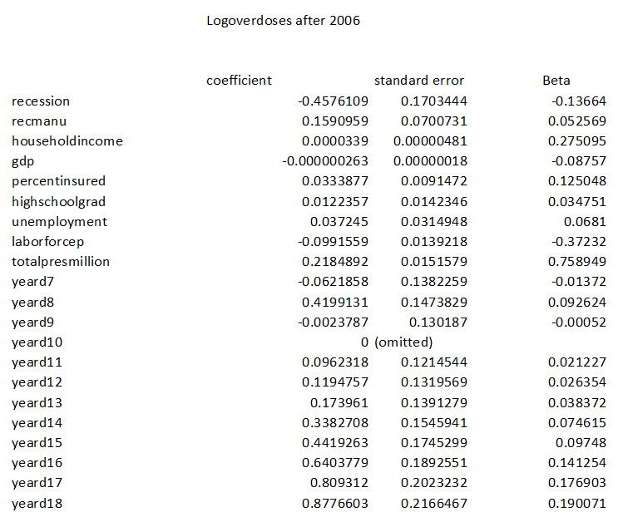

The regression results above (figure 3) account for the variables recession, recmanu, householdincome, GDP, percentinsured, highschoolgrad, unemployment, laborforcep, totalpresmillion, and years y through 18 with year 10 being omitted for collinearity. For every increase in one unit for the recession, GDP, laborforce participation, and the year of 2007 and 2009, we see a decrease in the rate of overdoses that occur. This is paired with an increase in overdoses that occur per increase in one unit for recmanu, household income, percent insured, high school grad, unemployment, totalpresmillion, and remaining years. These results apply to the rate of overdoses after the year 2006. The results suggest that GDP, highschoolgradrate, and unemployment rate are insignificant based on a statistical significance of 10%.

*Figure 4*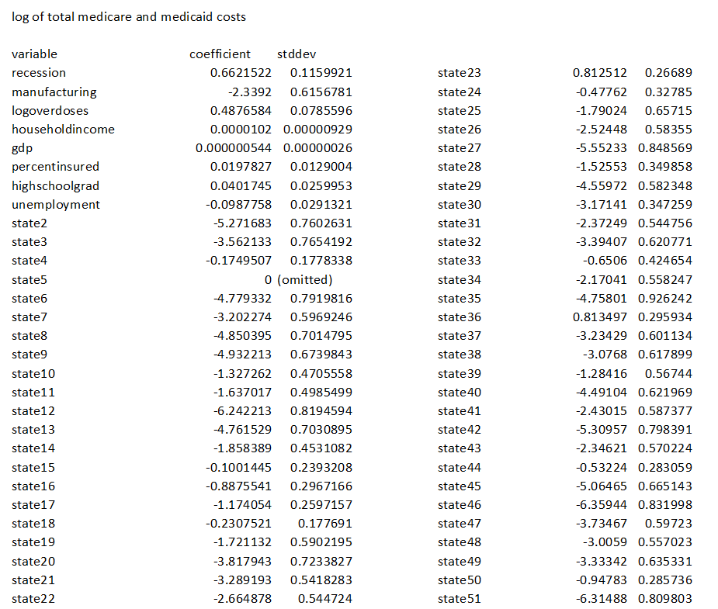

The results above (figure 4) account for the variables recession, manufacturing, logoverdoses, household income, GDP, percent insured, high school grad, unemployment, and all 51 states available. Per increase in one unit in manufacturing states, and unemployment there are decreases to the rate of total cost with increases in all other relevant variables. All variables are considered statistically significant at a statistical significance of 10% besides household income, percent insured, and high school grad.

Overall, the findings of the regression models show the most overdoses taking place before the year 2007, with certain variables predominately the high school grad rate being considered insignifict to both the rate of overdose and total cost.

*Figure 5*

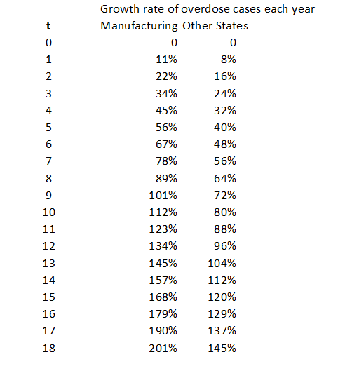

In figure 5 we are shown the rate of overdoses over the selected time period of 2000 t0 2018. We are comparing the rate of growth between manufacturing states and other states. The growth rate for manufacturing states is much larger than that of non-manufacturing states.

*Figure 6*

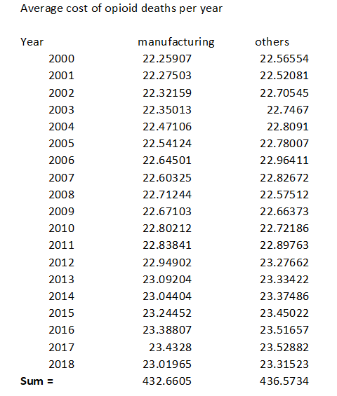

In figure 6 we are shown the average cost of opioid deaths per year within the selected time of 2000 to 2018 comparing the manufacturing states to the nonmanufacturing states. The cost from manufacturing states alone is close to the average cost of that of all other states. The average cost over the time period is approximately $870 million.

*Figure 7*

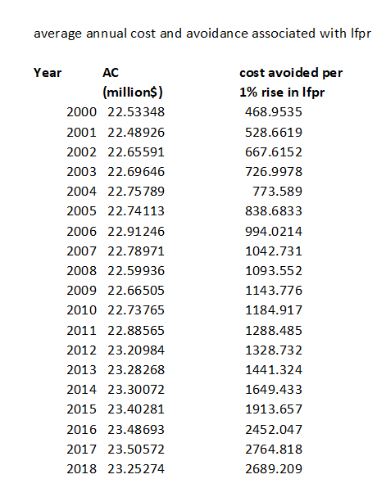

*In figure 7 we are observing the average costs overall per year associated with opioid deaths and the cost avoided with a 1% rise in labor force participation. Cost avoided increases over the years with labor force participation.*

*Figure 8*

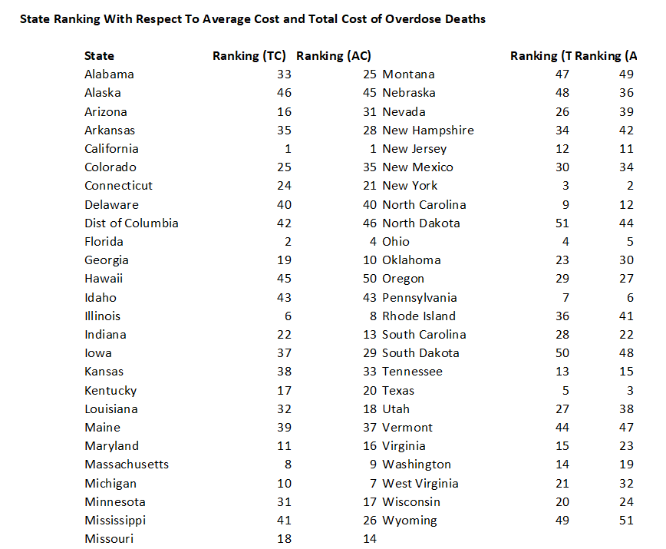

*In figure 8 we are looking at the rankings of the states ranked by total cost and average cost.*

Policy Implications and limitations

With the rate of overdose increasing in all states with the progression of time it is important to take swift action to combat the opioid epidemic. The results of the research conducted Ultimately reveal that there are higher rates of overdose and higher accumulated cost associated with the variables listed in figure 1. The demographic information reveals that there needs to be an emphasis on lawmaking towards opioid abuse and prescriptions for lower income households in predominately manufacturing states. This appears to be the case because more individuals in this demographic are doing manual labor and developing issues that require that they be treated for pain. Simulation results also reveal that increased labor force participation reduce the average cost associated with opioid deaths which holds the possibility of insinuating that rates of opioid related death could be higher in periods of economic recession. A limiting factor appears to be the ability to determine which areas are in fact more afflicted due to this epidemic as in the simulation California is ranked first in terms of number of overdose deaths as well as the total cost, yet California is not identified as a manufacturing state. This could be due to the large population in California however, to combat the issue it would not be useful to neglect enforcing policy on states based on population as the rate of overdose may be lower in scale to others the amount of those affected is still far greater; and those states that are smaller with a higher rate of overdose should not be passed over either. It is also difficult to set policy on a very specific demographic of people in all states without setting limitations on those who do not need them as much. While the demographic information is especially useful in determining which groups are being impacted the most, policy would have to be applied at a nationwide level to truly combat the epidemic.

*Conclusion:*

The opioid epidemic has had a major effect on the lives of many in the nation leading to overdose and increased costs associated with healthcare, thus costing a greater amount for the country. Based on data outlining several different demographics we are able to determine that the majority of the cost associated with opioid deaths has been impacted by those in manufacturing states and increasing over the time period of 2000 to 2018. Factors such as income and labor force participation indicate fluctuations that may occur with different economic cycles. The total cost overall associated with opioid related deaths averages at $1,043,703,757,894.74 over the time period outlined. This is paired with the average number of opioid deaths for all the years in the selected time period being 16,242. A large percentage (almost half of these amounts are accumulated by the

*Bibliography*

Dasgupta, N., Beletsky, L., & Ciccarone, D. (2018). Opioid Crisis: No Easy Fix to Its Social and Economic Determinants. *American journal of public health*, *108*(2), 182–186. <https://doi.org/10.2105/AJPH.2017.304187>

Parramore, Article By Lynn, et al. “Opioid Crisis Shows How Economic Inequality Kills.” *Institute for New Economic Thinking*, https://www.ineteconomics.org/perspectives/blog/opioid-crisis-shows-how-economic-inequality-kills.

Brill, Alex, and Scott Ganz. “The Geographic Variation in the Cost of the Opioid Crisis.” *Www.aei.org*, 20 Mar. 2018, https://www.aei.org/wp-content/uploads/2018/03/Geographic_Variation_in_Cost_of_Opioid_Crisis.pdf?x91208.

The Council of Economic Advisers. *The Role of Opioid Prices in the Evolving Opioid Crisis*. 2019, https://trumpwhitehouse.archives.gov/wp-content/uploads/2019/04/The-Role-of-Opioid-Prices-in-the-Evolving-Opioid-Crisis.pdf.

Adam Scavette, 2019. "[**Exploring the Economic Effects of the Opioid Epidemic**](https://ideas.repec.org/a/fip/fedpei/00036.html)," [Economic Insights](https://ideas.repec.org/s/fip/fedpei.html), Federal Reserve Bank of Philadelphia, vol. 4(2), pages 1-7, April.